# Process to install Github Desktop and get code from the 2019 version

1. Install the Github desktop app on your computer at <https://desktop.github.com/> . Make sure you have a Github account. This is optional, but you can download Github Desktop, and it makes the process of seeing edits and pushing code to Github a lot easier IMHO.
2. Go to VS Code, the gear symbol at the bottom, Settings then go to Extensions in the User interface (in settings), Git, and go down to Default Clone Directory type in C:\Users\Public\frc2019\workspace. (the reason for Public is because everyone has Public as a User)

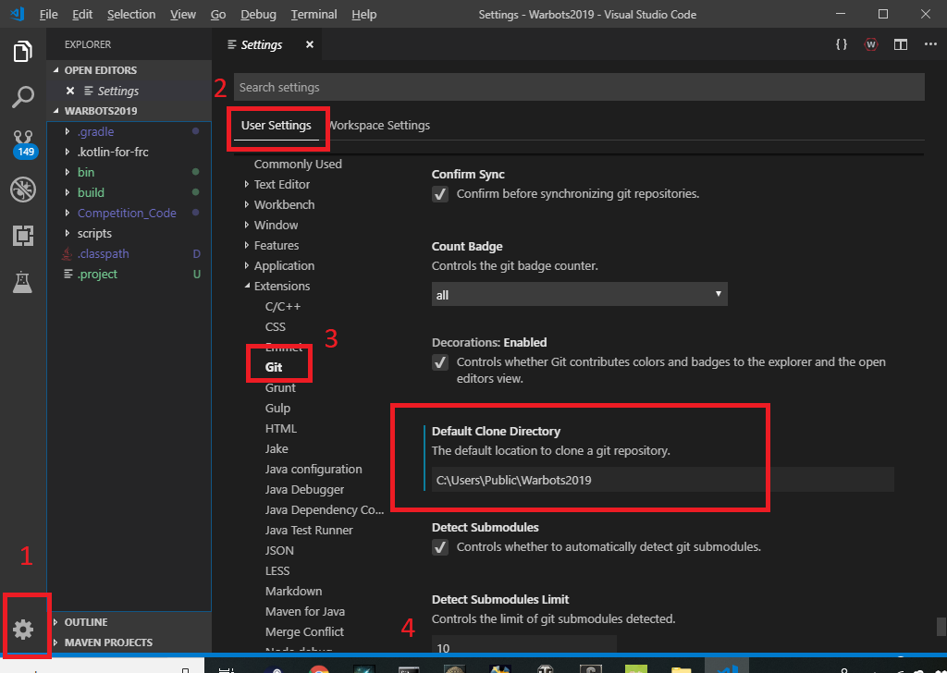

# How To:

## Get code from Repo (Repository) [first time]:

1. In VS Code, press Ctrl+Shift+P or go to View, Command Palette, and type in “git clone”

## Get changes from other people from REPO:

1. In VS Code, press Ctrl+Shift+P or go to View, Command Palette, and type in “git pull”

## Send changes to Repo

1. In VS Code, press Ctrl+Shift+P or go to View, Command Palette
2. type in “git commit -a -m “message””, the “message” part of “git commit -a -m “message”” allows you to attach a message to your changes. PLEASE ENTER REASONABLE AND INFORMATIVE MESSAGES, so people know why you made the change;
3. “git push”

Add a new file to Repo

Go to Github, the Repository, and click “Create new file” near the “Clone or download” at https://github.com/FRC-Team-620/Warbots2019

Delete a file from Repo

Go to Github, click on a file (.classpath for example) and click on the garbage can.

# “A day in the life.”

Here’s an example of Sam and Grace doing an original clone and then sharing changes.

1.

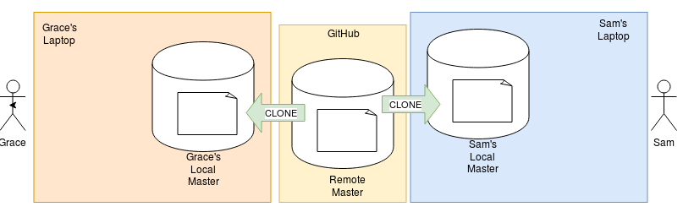

Grace and Sam clone the master repository

2.

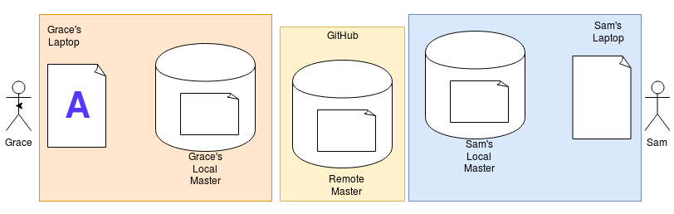

Grace makes edits to the code

3.

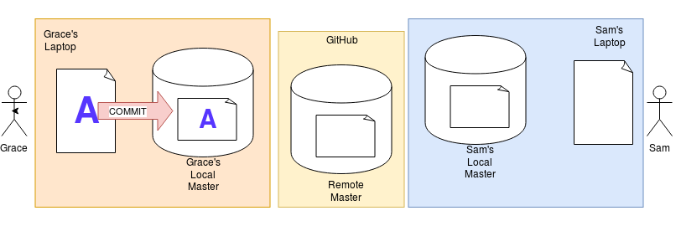

Grace Commits her changes to her local master

4.

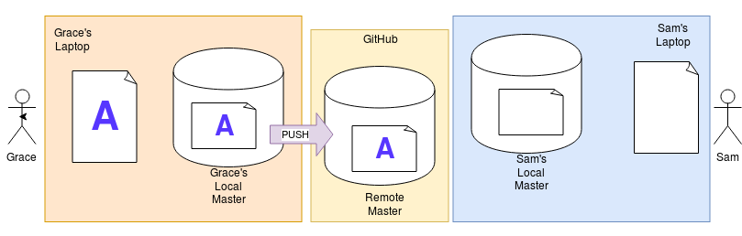

Grace pushes her code to Github. This effectively overwrites the remote master file with Grace’s local master file.

5.

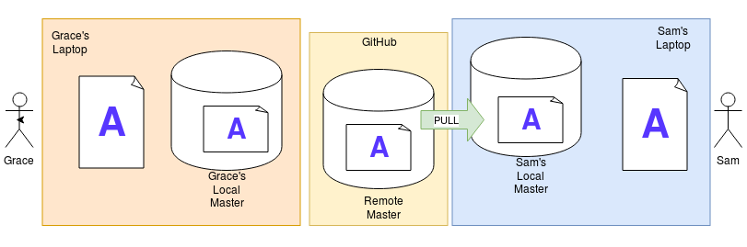

Sam pulls the code from Github. This is the point where remote master and local master changes are merged together.

**This I something Sam should do multiple times a day because we have many developers making lots of changes**

6.

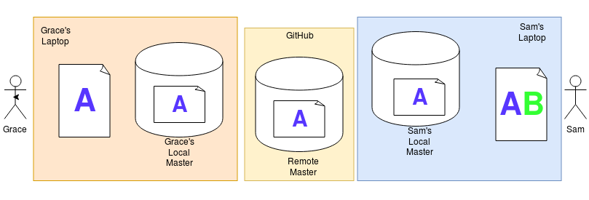

Sam makes edits to his code, B

7.

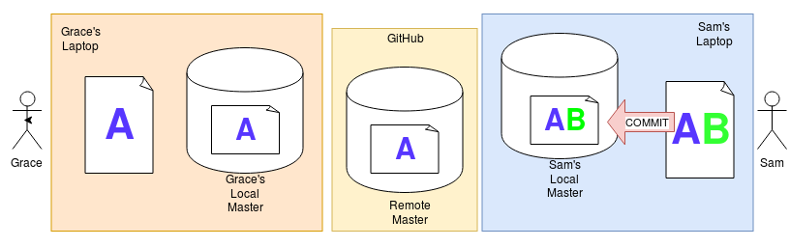

Sam commits his edits to his local master

**Sam wants to do this often once he has something that works so that his work is recoverable**

8.

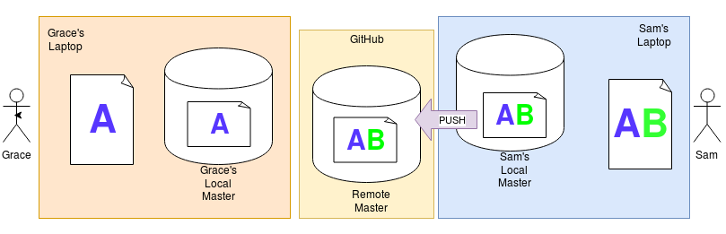

Sam pushes his changes to Github

**Sam should push at least once a day so others can see/ use his excellent work**

9.

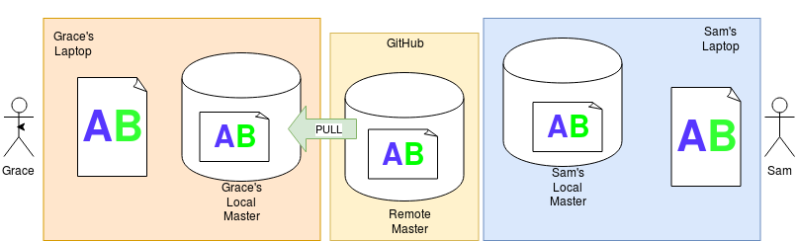

Graces pulls the updated code

**So the general pattern is: COMMIT, PULL, PUSH (CPP) These three commands should be executed immediately one after the other (as long as no errors show up :-P ) multiple times a day.**

**With CPP we are less likely to end up with having to merge lots complicated variations of code and we’re not stomping on each other.**